# DHCP Configuration

## Install and configure DHCP in Server machine

**1.1.1** Install DHCP for configuration



**1.1.2** configuration by nmtui



**1.1.3** Select Edit a connection

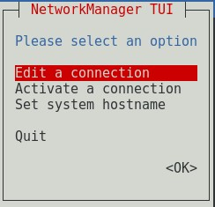

**1.1.4** Edit Wired connection 1 with Automatic IP configuration

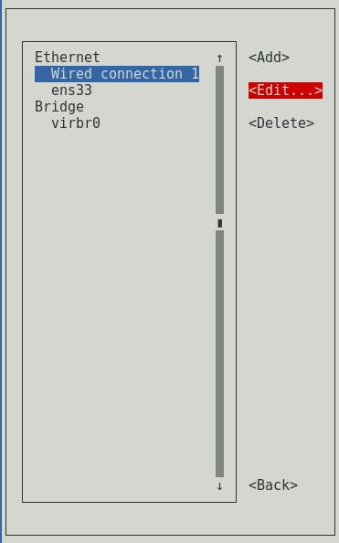

**1.1.5** Edit ens33 with Manual IPv4 configuration and go Back

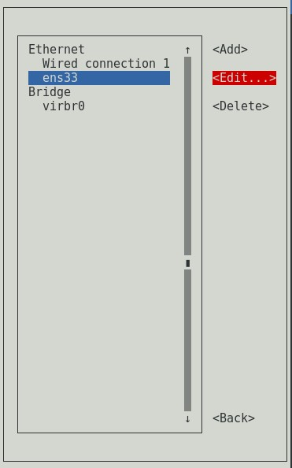

**1.1.6** Select Set system hostname and change the hostname as preferred

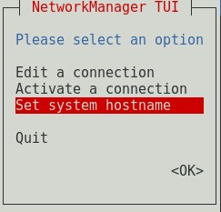

**1.1.7** Select Activate a connection and activate both network connections

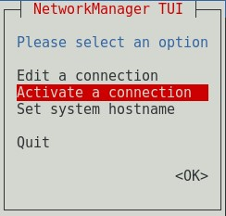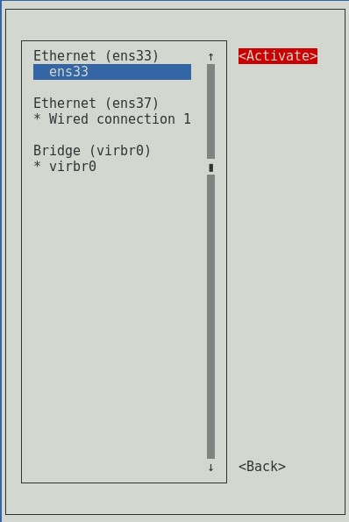

**1.1.8** Click OK to exit from Network Manager TUI

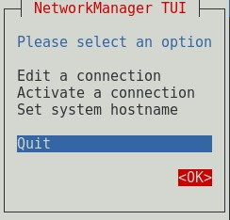

**1.1.9** Check network configuration using ifconfig



Figure 3.16: Check network details

**1.1.10** Open dhcpd file and add “DHCPDARGS=ens33” at the end of the file



**1.1.11** Check dhcpd configuration file



**1.1.12** Copy the file to another destination. Click tab twice to show version number



**1.1.13** Open dhcp configuration file and edit



**1.1.14** Check DHCP service status and start service



**1.1.15** Start DHCP service and enable DHCP service to start at the OS startup



* + 1. Check DHCP service status again



## 1.2 Configure DHCP in Client machine

**1.2.1** Following same procedure as previous open Network Manager with nmtui and Edit connection to Automatic DHCP

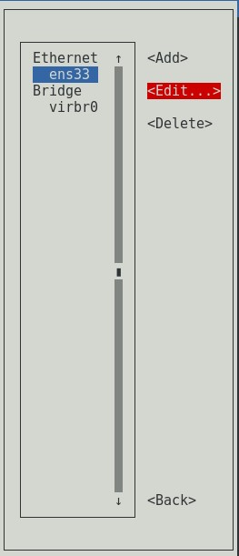

**1.2.2** Change hostname as preferred and activate the connection

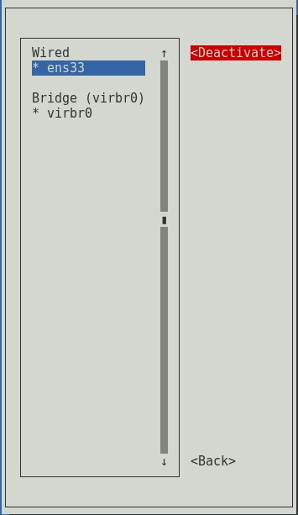

**1.2.3** Check received IP with ifconfig through DHCP server

